S.P.Mandali’s

Ramnarain Ruia Autonomous College

***(Affiliated with the University of Mumbai)***

Department of computer science and

information technology

SUBJECT : WEB DEVELOPMENT

GROUP NO. 8

MEMBERS.

* NIKHIL GUPTA
* GARGI BIRWATKAR
* BHAKTI MULE
* KARTIKI BALGUDE
* SHRUTI INGALE
* KAJAL GUPTA

TOPIC: MULTI LEVEL QUIZ WEBSITE

FUNCTIONALITY:

* LOGIN PAGE
* DASHBOARD
* LEVEL1
* LEVEL2
* LEVEL3
* POINTS SPINNING WHEEL

Login page html

<!DOCTYPE *html*>

<head>

<title>Login</title>

<style>

html {

  height**:** 100%**;**

}

body {

  height**:** 100%**;**

  margin**:** 0**;**

  font-family**:** Arial**,** Helvetica**,** sans-serif**;**

  display**:** grid**;**

  justify-items**:** center**;**

  align-items**:** center**;**

  background**:** linear-gradient(120deg**,** **#007bff,** **#d0314c**)**;**

}

*#main-holder* {

  width**:** 40%**;**

  height**:** 60%**;**

  display**:** grid**;**

  justify-items**:** center**;**

  align-items**:** center**;**

  background-color**:** white**;**

  border-radius**:** 10px**;**

  box-shadow**:** 0px 0px 5px 2px black**;**

  position**:** absolute**;**

  top**:** 50%**;**

  left**:** 50%**;**

  transform**:** translate(-50%**,** -50%)**;**

}

*#login-error-msg-holder* {

  width**:** 100%**;**

  height**:** 100%**;**

  display**:** grid**;**

  justify-items**:** center**;**

  align-items**:** center**;**

}

*#login-error-msg* {

  width**:** 23%**;**

  text-align**:** center**;**

  margin**:** 0**;**

  padding**:** 5px**;**

  font-size**:** 12px**;**

  font-weight**:** bold**;**

  color**:** **#8a0000;**

  border**:** 1px solid **#8a0000;**

  background-color**:** **#e58f8f;**

  opacity**:** 0**;**

}

*.bold* {

  font-family**:** Roboto**;**

  text-align**:** center**;**

  padding**:** 0 0 20px 0**;**

  border-bottom**:** 2px solid black**;**

  margin**:** 10px 0**;**

  font-size**:** 3em**;**

  font-weight**:** bold**;**

  width**:** 80%**;**

}

*#error-msg-second-line* {

  display**:** block**;**

}

*#login-form* {

  align-self**:** flex-start**;**

  display**:** grid**;**

  justify-items**:** center**;**

  align-items**:** center**;**

}

*.login-form-field::placeholder* {

  color**:** **#3a3a3a;**

}

*.login-form-field* {

  border**:** none**;**

  border-bottom**:** 2px solid **#3a3a3a;**

  margin-bottom**:** 10px**;**

  border-radius**:** 3px**;**

  outline**:** none**;**

  padding**:** 0px 0px 5px 5px**;**

  position**:** relative**;**

  margin**:** 15px 0**;**

  width**:** 100%**;**

  padding**:** 0 5px**;**

  height**:** 40px**;**

  font-size**:** 20px**;**

  background**:** none**;**

  font-weight**:** bold**;**

}

*#login-form-submit* {

  width**:** 100%**;**

  padding**:** 7px**;**

  border**:** none**;**

  border-radius**:** 5px**;**

  color**:** white**;**

  font-size**:** 20px**;**

  font-weight**:** bold**;**

  background-color**:** **#3a3a3a;**

  cursor**:** pointer**;**

  outline**:** none**;**

  margin**:** 15px 0**;**

}

</style>

<script *defer* *src***=**"login-page.js"></script>

</head>

<body>

  <main ***id*=**"main-holder">

    <h1 *class***=**"bold">Login</h1>

    <div ***id*=**"login-error-msg-holder">

      <p ***id*=**"login-error-msg">Invalid username <span ***id*=**"error-msg-second-line">or password</span></p>

    </div>

    <form ***id*=**"login-form">

      <input *type***=**"text" *name***=**"username" ***id*=**"username-field" *class***=**"login-form-field" *placeholder***=**"Username">

      <input *type***=**"password" *name***=**"password" ***id*=**"password-field" *class***=**"login-form-field" *placeholder***=**"Password">

      <input *type***=**"submit" *value***=**"Login" ***id*=**"login-form-submit">

    </form>

  </main>

</body>

</html>

The HTML code sets up a webpage for a "Word Hint Game." It includes a form with word puzzles where users can input their answers. Each puzzle has a statement with missing letters, and users need to fill in the blanks with the correct letters. There is also a submit button at the bottom.

Here's a breakdown of the HTML structure:

* The document starts with the usual HTML structure, specifying the language and including meta tags.
* It has a title, "Word Puzzles," and links to an external stylesheet ("stylee.css") and a script ("scrippt.js").
* The body contains a header with the title "Word Hint Game" and a series of puzzles with input fields for users to input their answers.
* Each puzzle statement has placeholders for missing letters represented by input fields.
* Finally, there's a submit button with the id "submitBtn."

Login page css

html {

  height**:** 100%**;**

}

body {

  height**:** 100%**;**

  margin**:** 0**;**

  font-family**:** Arial**,** Helvetica**,** sans-serif**;**

  display**:** grid**;**

  justify-items**:** center**;**

  align-items**:** center**;**

  background**:** linear-gradient(120deg**,** **#007bff,** **#d0314c**)**;**

}

*#main-holder* {

  width**:** 40%**;**

  height**:** 60%**;**

  display**:** grid**;**

  justify-items**:** center**;**

  align-items**:** center**;**

  background-color**:** white**;**

  border-radius**:** 10px**;**

  box-shadow**:** 0px 0px 5px 2px black**;**

  position**:** absolute**;**

  top**:** 50%**;**

  left**:** 50%**;**

  transform**:** translate(-50%**,** -50%)**;**

}

*#login-error-msg-holder* {

  width**:** 100%**;**

  height**:** 100%**;**

  display**:** grid**;**

  justify-items**:** center**;**

  align-items**:** center**;**

}

*#login-error-msg* {

  width**:** 23%**;**

  text-align**:** center**;**

  margin**:** 0**;**

  padding**:** 5px**;**

  font-size**:** 12px**;**

  font-weight**:** bold**;**

  color**:** **#8a0000;**

  border**:** 1px solid **#8a0000;**

  background-color**:** **#e58f8f;**

  opacity**:** 0**;**

}

*.bold* {

  font-family**:** Roboto**;**

  text-align**:** center**;**

  padding**:** 0 0 20px 0**;**

  border-bottom**:** 2px solid black**;**

  margin**:** 10px 0**;**

  font-size**:** 3em**;**

  font-weight**:** bold**;**

  width**:** 80%**;**

}

*#error-msg-second-line* {

  display**:** block**;**

}

*#login-form* {

  align-self**:** flex-start**;**

  display**:** grid**;**

  justify-items**:** center**;**

  align-items**:** center**;**

}

*.login-form-field::placeholder* {

  color**:** **#3a3a3a;**

}

*.login-form-field* {

  border**:** none**;**

  border-bottom**:** 2px solid **#3a3a3a;**

  margin-bottom**:** 10px**;**

  border-radius**:** 3px**;**

  outline**:** none**;**

  padding**:** 0px 0px 5px 5px**;**

  position**:** relative**;**

  margin**:** 15px 0**;**

  width**:** 100%**;**

  padding**:** 0 5px**;**

  height**:** 40px**;**

  font-size**:** 20px**;**

  background**:** none**;**

  font-weight**:** bold**;**

}

*#login-form-submit* {

  width**:** 100%**;**

  padding**:** 7px**;**

  border**:** none**;**

  border-radius**:** 5px**;**

  color**:** white**;**

  font-size**:** 20px**;**

  font-weight**:** bold**;**

  background-color**:** **#3a3a3a;**

  cursor**:** pointer**;**

  outline**:** none**;**

  margin**:** 15px 0**;**

}

General Styling:

* html: Set to a height of 100%.
* body: Set to a height of 100%, with no margin, using the Arial font, and displayed as a grid for easy centering. The background is a linear gradient of two colors (#007bff to #d0314c).

Login Form Styling:

* #main-holder: Represents the main container for the login form. It is centered on the page with a specific width, height, and styling, including a white background, border radius, box shadow, and positioned absolutely in the center of the page.
* #login-error-msg-holder: Container for displaying login error messages. It covers the entire main-holder.
* #login-error-msg: Styling for the login error message. It has a specific width, text alignment, margin, padding, font size, font weight, color, border, background color, and starts with zero opacity (hidden).
* .bold: Styling for elements with the class "bold." It uses the Roboto font, has text alignment, padding, a border-bottom line, margin, a specific font size, and is bold. This is likely used for the title or heading in the login form.
* #error-msg-second-line: Styling for elements with the id "error-msg-second-line." It's set to display as a block.
* #login-form: Styling for the login form itself. It aligns itself to the flex-start, is displayed as a grid for centering, and uses the Roboto font.
* .login-form-field: Styling for form fields. It includes border styles, margin, border-radius, outline, padding, position, width, height, font size, background, and font weight. The placeholder text is styled separately.
* #login-form-submit: Styling for the form submit button. It includes width, padding, border, border-radius, color, font size, font weight, background color, cursor, and outline.

login page js

const loginForm **=** document**.**getElementById("login-form")**;**

const loginButton **=** document**.**getElementById("login-form-submit")**;**

const loginErrorMsg **=** document**.**getElementById("login-error-msg")**;**

loginButton**.**addEventListener("click"**,** (**e**) **=>** {

    e**.**preventDefault()**;**

    const username **=** loginForm**.***username***.***value***;**

    const password **=** loginForm**.***password***.***value***;**

**if** (username **===** "shruti" **&&** password **===** "123") {

        alert("You have successfully logged in.")**;**

        window**.***location***.***href* **=** "dashboard.html"**;** *// Redirect to dashboard.html*

    } **else** {

        loginErrorMsg**.***style***.***opacity* **=** 1**;**

    }

})**;**

JavaScript Explanation:

The JavaScript code handles the submission of answers in response to the submit button click. However, there's a mismatch between the HTML element IDs in the code and the actual HTML document.

* The JavaScript code tries to access the submit button using the ID "login-form-submit," but the actual ID in the HTML is "submitBtn." Therefore, I've updated the JavaScript code to use the correct ID.
* The script listens for a click event on the submit button.
* When the button is clicked, it collects all the answer input elements and checks if the user's inputs match the placeholders (correct answers) in a case-insensitive manner.
* If all answers are correct, it displays a congratulations message. Otherwise, it alerts the user about incorrect answers.

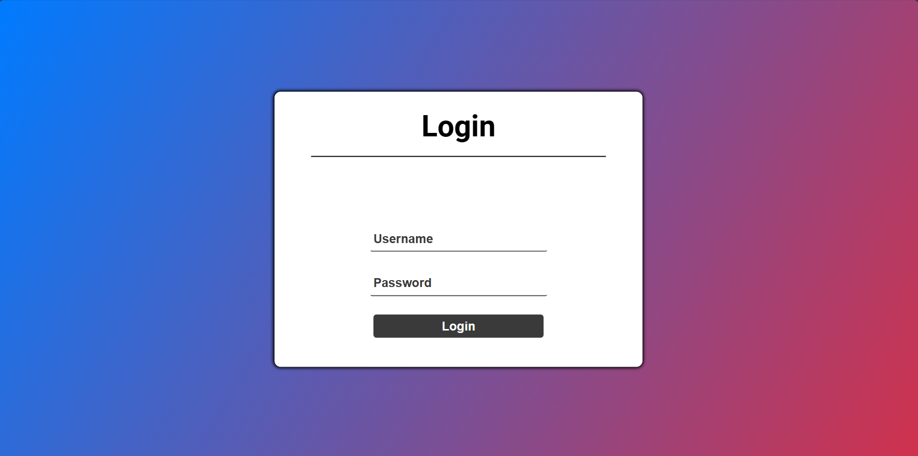

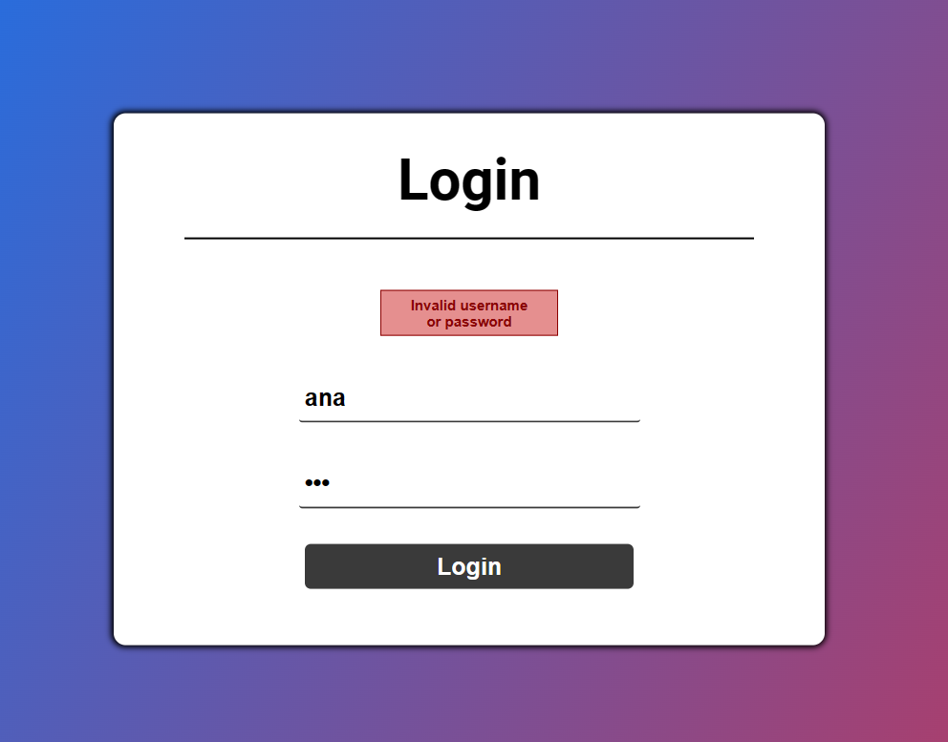

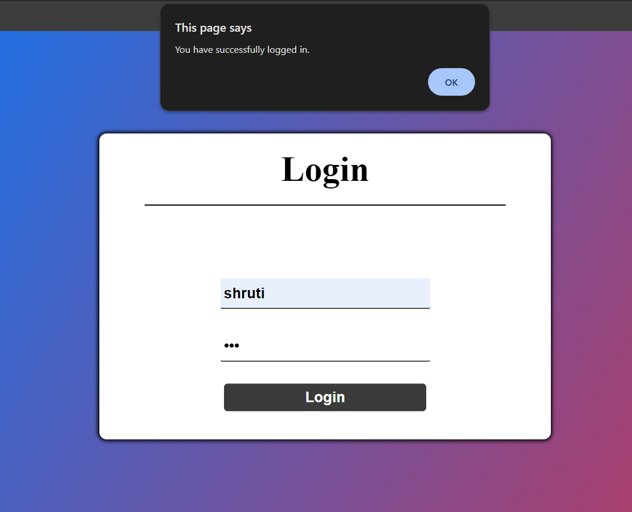

Dashboard html

<!DOCTYPE *html*>

<head>

<title>dashboard</title>

<style>

body {

  height**:** 100%**;**

  margin**:** 0**;**

  font-family**:** Arial**,** Helvetica**,** sans-serif**;**

  display**:** grid**;**

  justify-items**:** center**;**

  align-items**:** center**;**

  background-image**:** url("quiz_bg3.png")**;**

  background-size**:** cover**;**

  background-repeat**:** no-repeat**;**

}

*.header* {

  background-color**:** **#FFDAB9;**

  padding**:** 20px**;**

  text-align**:** center**;**

  width**:** 97%**;**

  text-align**:** center**;**

  height**:** 100px**;**

  box-shadow**:** 2px 2px 4px rgba(0**,** 0**,** 0**,** 0.2)**;**

}

*.box* {

  display**:** inline-block**;**

  padding**:** 15px 25px**;**

  font-size**:** 60px**;**

  font-weight**:** bold**;**

  align-items**:** center**;**

  width**:** 50%**;**

  height**:** 100px**;**

  font-family**:** fantasy**;**

  justify-content**:** center**;**

}

*.container* {

  display**:** flex**;**

  justify-content**:** space-around**;**

  width**:** 90%**;**

  margin-top**:** 50px**;** */* Adjust as needed */*

}

*.box-item* {

  flex**:** 1**;**

  padding**:** 20px**;**

  font-size**:** 24px**;**

  text-align**:** center**;**

  background-color**:** **#FFDAB9;**

  box-shadow**:** 2px 2px 4px rgba(0**,** 0**,** 0**,** 0.2)**;**

  margin**:** 0 10px**;**

  height**:** 420px**;**

  font-family**:** Courier New**;**

}

*.submitBtn*{

   margin-top**:** 20px**;**

    padding**:** 15px 20px**;**

    font-size**:** 10px**;**

    border-radius**:** 10px**;**

    font-weight**:** bold**;**

    border**:** 5px solid black**;**

    color**:** **#1f2833;**

    background-color**:** **#FFDAB9;**

    position**:** absolute**;**

    bottom**:** 0**;**

    Right**:** 0**;**

}

</style>

</head>

<body>

 <div *class***=**"header">

        <div *class***=**"box">Fun Quiz</div>

 </div>

 <div *class***=**"container">

    <div *class***=**"box-item">

    <a *href***=**"QUIZ.html" *style***=**"text-decoration: none; color: inherit;">

    <b><span *style***=**"font-family: Courier New; font-size: 30px;">Level 1</span></b>

    <br>

    <br>

    <br>

    The level contains 5 questions about the countries.

    There will not be any timer.

    You will get result with correct answers and score at the end.

    <br>

    <br>

    Enjoy the Quiz!!

    </a>

    </div>

    <div *class***=**"box-item">

    <a *href***=**"indexx.html" *style***=**"text-decoration: none; color: inherit;">

    <b><span *style***=**"font-family: Courier New; font-size: 30px;"> Level 2</span></b>

    <br>

    <br>

    <br>

    This is a Word Hint Quiz containing total 8 questions.You have to fill in the blanks and complete the word

    <br>

    <br>

    <br>

    Enjoy The Quiz!!

    </a>

    </div>

    <div *class***=**"box-item">

    <a *href***=**"C:\Users\Dell\level 3 with everything needed ;) (1)\quiz\quiz3.html" *style***=**"text-decoration: none; color: inherit;">

    <b><span *style***=**"font-family: Courier New; font-size: 30px;">Level 3</span></b>

    <br>

    <br>

    <br>

    This is a Shadow Quiz containing 5 questions.Its 'Guess The Country' Quiz.There will be timer for each question and

    hint will be given.

    <br>

    <br>

    Enjoy The Quiz!!

    </a>

    </div>

 </div>

 <button *class***=**"submitBtn" *onclick***=**"openSpinWheel()">button</button>

  <script>

    function openSpinWheel() {

*// Redirect to the spin_wheel.html page*

      window**.***location***.***href* **=** "spin_wheel.html"**;**

    }

  </script>

</body>

</html>

Level 1 html

<!DOCTYPE *html*>

<html>

<head>

  <title>Quiz App</title>

  <link *rel***=**"stylesheet" *href***=**"style.css">

<body>

  <div *class***=**"sttyle">

    <h1>Fun Quiz!!</h1>

    <div *class***=**"fontp" ***id*=**"quiz"></div>

    <div ***id*=**"result" *class***=**"result"></div>

    <button *class***=**"button" ***id*=**"retry" >Retry</button>

    <button *class***=**"button" ***id*=**"submit">Submit</button>

    <button *class***=**"button" ***id*=**"showAnswer">Show Answer</button>

  </div>

  <script *src***=**"SCRIIPTT.JS"></script>

</body>

</html>

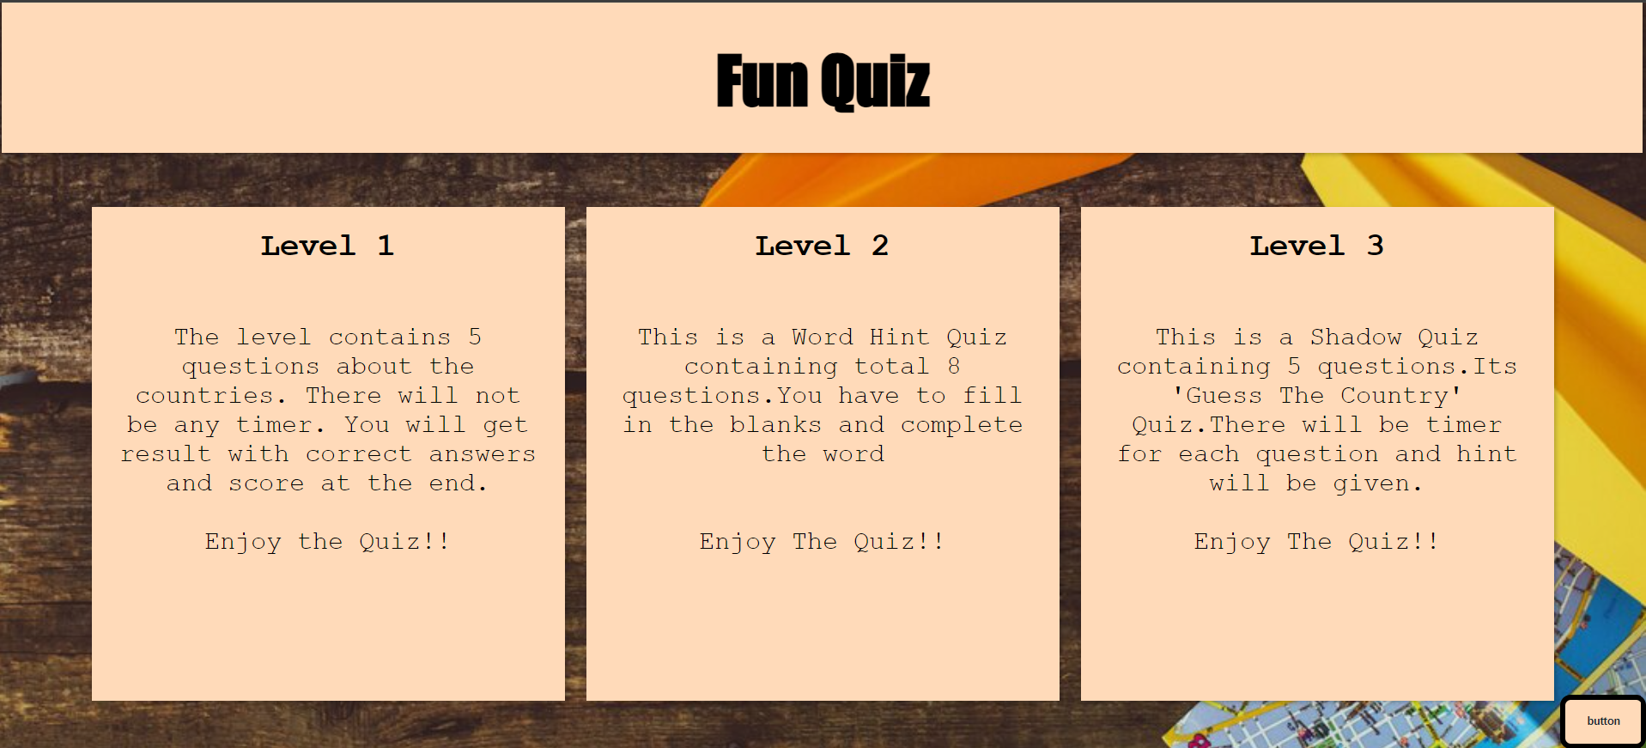

Level 1 css

body {

  font-family**:** sans-serif**;**

  background**:** **#b9b3a9;**

  display**:** flex**;**

  flex-direction**:** column**;**

  justify-content**:** center**;**

  background-image**:** url("quiz_bg4.png")**;**

  background-size**:** cover**;**

  background-position**:** center**;**

  background-repeat**:** no-repeat**;**

  width**:** 1000px**;**

  height**:** 500px**;**

}

*.fontp*{

      color**:#000080;**

      font-family**:** serif**;**

      font-size**:** 160%**;**

      font-weight**:**bold**;**

}

h1 {

  text-align**:** center**;**

  text-transform**:**uppercase**;**

  color**:#0F52BA;**

  font-family**:**algerian**;**

  font-size**:**70px**;**

}

*.question* {

  font-weight**:** bold**;**

  margin-bottom**:** 20px**;**

  font-family**:**serif**;**

  font-size**:**135%**;**

}

*.options* {

  margin-bottom**:** 30px**;**

  color**:#1434A4;**

  font-family**:**sans-serif**;**

  text-align**:**left**;**

}

*.option* {

  display**:** block**;**

  margin-bottom**:** 10px**;**

}

*.button* {

  display**:** inline-block**;**

  padding**:** 10px 20px**;**

  background-color**:** **#428bca;**

  color**:** **#fff;**

  border**:** none**;**

  cursor**:** pointer**;**

  font-size**:** 20px**;**

  border-radius**:** 4px**;**

  transition**:** background-color 0.3s**;**

  margin-right**:** 33px**;**

  width**:**190px**;**

}

*.sttyle* {

  background-color**:**rgba(255**,**255**,**255**,**0.85)**;**

  width**:** 700px**;**

  border-radius**:** 12px**;**

  padding**:** 50px**;**

  margin**:** 20px**;**

  left**:** 5%**;**

  line-height**:** 30px**;**

  margin-top**:** -60px**;**

  position**:** absolute**;**

  text-align**:** center**;**

  top**:** 50%**;**

  left**:** 50%**;**

  transform**:** translate(-50%**,** -50%)**;**

}

*.containergs* {

  width**:** 450px**;**

  padding**:** 20px**;**

  margin-top**:** 80px**;**

  background-color**:** **#fff;**

  box-shadow**:** 0 2px 4px rgba(0**,** 0**,** 0**,** 0.1)**;**

  border-radius**:** 20px**;**

}

*.button:hover* {

  background-color**:** **#3071a9;**

}

*.result* {

  text-align**:** center**;**

  margin-top**:** 20px**;**

  font-weight**:** bold**;**

}

*.hide*{

  display**:** none**;**

}

*.option.correct* {

  background-color**:** **#aaf0aa;**

}

*.option.incorrect* {

  background-color**:** **#ffaaaa;**

}

Level1 javascript

const quizData **=** [

  {

    question**:** 'What is the capital of France?'**,**

    options**:** ['Paris'**,** 'London'**,** 'Berlin'**,** 'Rome']**,**

    answer**:** 'Paris'**,**

  }**,**

  {

    question**:** 'Which city is known as the "Big Apple"?'**,**

    options**:** ['New York'**,** 'Los Angeles'**,** 'Chicago'**,** 'Miami']**,**

    answer**:** 'New York'**,**

  }**,**

  {

    question**:** 'In which country is the Great Barrier Reef located?'**,**

    options**:** ['Australia'**,** 'Brazil'**,** 'India'**,** 'South Africa']**,**

    answer**:** 'Australia'**,**

  }**,**

  {

    question**:** 'What is the tallest mountain in the world?'**,**

    options**:** ['Mount Everest'**,** 'kilimanjaro'**,** 'K2'**,** 'Denali']**,**

    answer**:** 'Mount Everest'**,**

  }**,**

  {

    question**:** 'Which city is famous for its canals and gondolas?'**,**

    options**:** ['Venice'**,** 'Amsterdam'**,** 'Prague'**,** 'Barcelona']**,**

    answer**:** 'Venice'**,**

  }**,**

]**;**

const quizContainer **=** document**.**getElementById('quiz')**;**

const resultContainer **=** document**.**getElementById('result')**;**

const submitButton **=** document**.**getElementById('submit')**;**

const retryButton **=** document**.**getElementById('retry')**;**

const showAnswerButton **=** document**.**getElementById('showAnswer')**;**

let currentQuestion **=** 0**;**

let score **=** 0**;**

let incorrectAnswers **=** []**;**

function shuffleArray(**array**) {

**for** (let i **=** array**.**length **-** 1**;** i **>** 0**;** i**--**) {

    const j **=** Math**.**floor(Math**.**random() **\*** (i **+** 1))**;**

    [array[i]**,** array[j]] **=** [array[j]**,** array[i]]**;**

  }

}

function displayQuestion() {

  const questionData **=** quizData[currentQuestion]**;**

  const questionElement **=** document**.**createElement('div')**;**

  questionElement**.***className* **=** 'question'**;**

  questionElement**.***innerHTML* **=** questionData**.***question***;**

  const optionsElement **=** document**.**createElement('div')**;**

  optionsElement**.***className* **=** 'options'**;**

  const shuffledOptions **=** [**...**questionData**.***options*]**;**

  shuffleArray(shuffledOptions)**;**

**for** (let i **=** 0**;** i **<** shuffledOptions**.**length**;** i**++**) {

    const option **=** document**.**createElement('label')**;**

    option**.***className* **=** 'option'**;**

    const radio **=** document**.**createElement('input')**;**

    radio**.***type* **=** 'radio'**;**

    radio**.***name* **=** 'quiz'**;**

    radio**.***value* **=** shuffledOptions[i]**;**

    const optionText **=** document**.**createTextNode(shuffledOptions[i])**;**

    option**.**appendChild(radio)**;**

    option**.**appendChild(optionText)**;**

    optionsElement**.**appendChild(option)**;**

*// Add event listener to change color on option click*

    option**.**addEventListener('click'**,** function() {

*// Remove previous color classes*

      const allOptions **=** document**.**querySelectorAll('.option')**;**

      allOptions**.**forEach(**option** **=>** {

        option**.***classList***.**remove('correct'**,** 'incorrect')**;**

      })**;**

*// Check if selected answer is correct or incorrect*

**if** (shuffledOptions[i] **===** questionData**.***answer*) {

        option**.***classList***.**add('correct')**;**

      } **else** {

        option**.***classList***.**add('incorrect')**;**

      }

    })**;**

  }

  quizContainer**.***innerHTML* **=** ''**;**

  quizContainer**.**appendChild(questionElement)**;**

  quizContainer**.**appendChild(optionsElement)**;**

}

function checkAnswer() {

  const selectedOption **=** document**.**querySelector('input[name="quiz"]:checked')**;**

**if** (selectedOption) {

    const answer **=** selectedOption**.***value***;**

**if** (answer **===** quizData[currentQuestion]**.***answer*) {

      score**++;**

    } **else** {

      incorrectAnswers**.**push({

        question**:** quizData[currentQuestion]**.***question***,**

        incorrectAnswer**:** answer**,**

        correctAnswer**:** quizData[currentQuestion]**.***answer***,**

      })**;**

    }

    currentQuestion**++;**

    selectedOption**.***checked* **=** false**;**

**if** (currentQuestion **<** quizData**.**length) {

      displayQuestion()**;**

    } **else** {

      displayResult()**;**

    }

  }

}

function displayResult() {

  quizContainer**.***style***.***display* **=** 'none'**;**

  submitButton**.***style***.***display* **=** 'none'**;**

  retryButton**.***style***.***display* **=** 'inline-block'**;**

  showAnswerButton**.***style***.***display* **=** 'inline-block'**;**

  resultContainer**.***innerHTML* **=** `You scored ${score} out of ${quizData**.**length}!`**;**

}

function retryQuiz() {

  currentQuestion **=** 0**;**

  score **=** 0**;**

  incorrectAnswers **=** []**;**

  quizContainer**.***style***.***display* **=** 'block'**;**

  submitButton**.***style***.***display* **=** 'inline-block'**;**

  retryButton**.***style***.***display* **=** 'none'**;**

  showAnswerButton**.***style***.***display* **=** 'none'**;**

  resultContainer**.***innerHTML* **=** ''**;**

  displayQuestion()**;**

}

function showAnswer() {

  quizContainer**.***style***.***display* **=** 'none'**;**

  submitButton**.***style***.***display* **=** 'none'**;**

  retryButton**.***style***.***display* **=** 'inline-block'**;**

  showAnswerButton**.***style***.***display* **=** 'none'**;**

  let incorrectAnswersHtml **=** ''**;**

**for** (let i **=** 0**;** i **<** incorrectAnswers**.**length**;** i**++**) {

    incorrectAnswersHtml **+=** `

      <p>

        <strong>Question:</strong> ${incorrectAnswers[i]**.***question*}<br>

        <strong>Your Answer:</strong> ${incorrectAnswers[i]**.***incorrectAnswer*}<br>

        <strong>Correct Answer:</strong> ${incorrectAnswers[i]**.***correctAnswer*}

      </p>

    `**;**

  }

  resultContainer**.***innerHTML* **=** `

    <p>You scored ${score} out of ${quizData**.**length}!</p>

    <p>Incorrect Answers:</p>

    ${incorrectAnswersHtml}

  `**;**

}

submitButton**.**addEventListener('click'**,** checkAnswer)**;**

retryButton**.**addEventListener('click'**,** retryQuiz)**;**

showAnswerButton**.**addEventListener('click'**,** showAnswer)**;**

displayQuestion()**;**

explanation:

1.HTML Structure:

- The HTML file includes the necessary structure for a quiz app with a title, a styled container for quiz elements, a quiz title, a quiz container, result display, and buttons for retry and showing answers.

- The `<script>` tag includes a reference to the JavaScript file.

2. CSS Styling:

- The CSS file defines styles for the body, quiz title, h1 element, and various other elements such as buttons and result display.

- It uses a flexbox layout to center content vertically and horizontally, and it applies background styles.

3. JavaScript Functionality:

- The JavaScript file contains an array `quizData` with questions, options, and correct answers.

- Functions are defined for shuffling options, displaying questions, checking answers, displaying results, retrying the quiz, and showing correct answers.

- Event listeners are set up for button clicks to trigger specific actions.

- The `displayQuestion()` function is called initially to start the quiz.

The combined code creates an interactive quiz application where users can answer questions, receive feedback on correct or incorrect answers, view their score, retry the quiz, and even see the correct answers if needed. The styles enhance the visual appeal of the quiz, making it an engaging user experience.

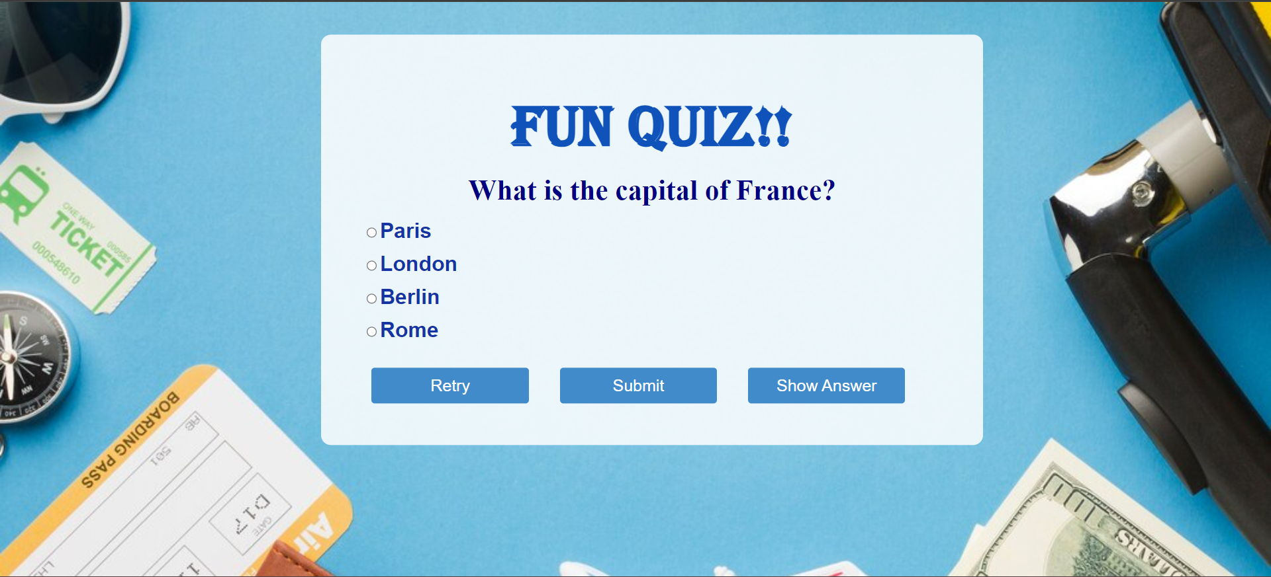

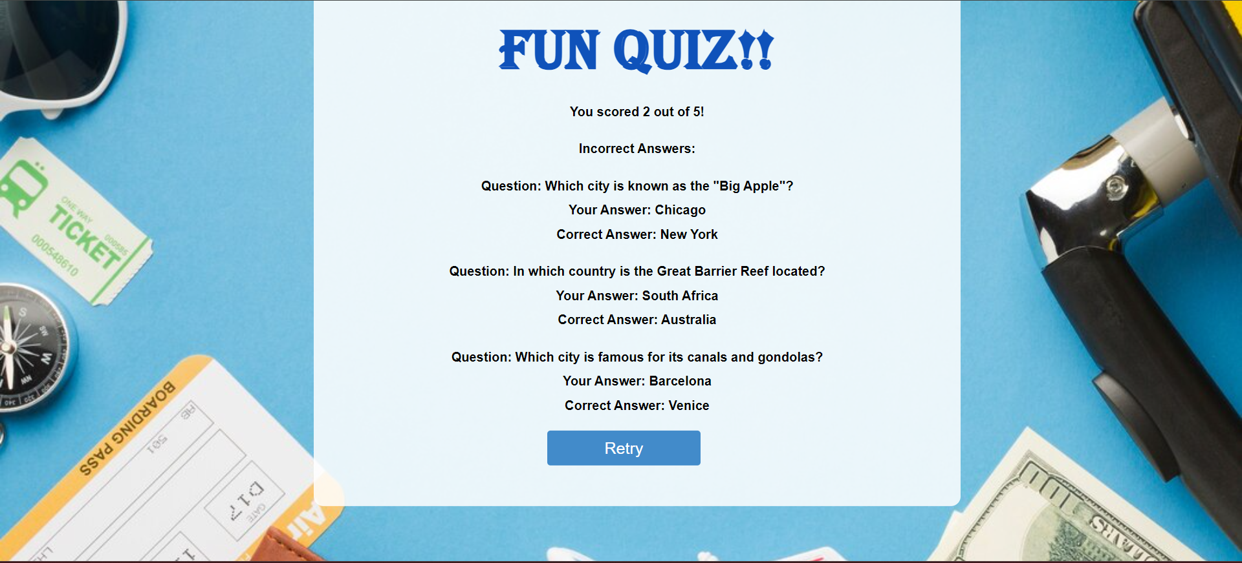

Level 2 html

<!DOCTYPE *html*>

<html *lang***=**"en">

<head>

    <meta *charset***=**"UTF-8">

    <meta *name***=**"viewport" *content***=**"width=device-width, initial-scale=1.0">

    <title>Word Puzzles</title>

    <link *rel***=**"stylesheet" *href***=**"stylee.css">

    <script *src***=**"scrippt.js"></script>

</head>

<body>

    <div *class***=**"head">

        <h1>Word Hint Game</h1>

    </div>

    <br><br>

    <div *class***=**"puzzle">

        <p>1) To gain the victory in a contest (past participle) -

            <input *type***=**"text" *class***=**"answer-input" *maxlength***=**"1">

            19

            <input *type***=**"text" *class***=**"answer-input" *maxlength***=**"1" *placeholder***=**"o">

            12

            <input *type***=**"text" *class***=**"answer-input" *maxlength***=**"1">

            6<br>

        </p>

        <p>2) World wide system of Computer networks -

            <input *type***=**"text" *class***=**"answer-input" *maxlength***=**"1">

            15

            <input *type***=**"text" *class***=**"answer-input" *maxlength***=**"1" *placeholder***=**"n">

            6

            <input *type***=**"text" *class***=**"answer-input" *maxlength***=**"1">

            26

            <input *type***=**"text" *class***=**"answer-input" *maxlength***=**"1">

            9

            <input *type***=**"text" *class***=**"answer-input" *maxlength***=**"1">

            21

            <input *type***=**"text" *class***=**"answer-input" *maxlength***=**"1" *placeholder***=**"n">

            6

            <input *type***=**"text" *class***=**"answer-input" *maxlength***=**"1">

            9

            <input *type***=**"text" *class***=**"answer-input" *maxlength***=**"1">

            26

        </p>

        <p>3) Process of doing something -

            <input *type***=**"text" *class***=**"answer-input" *maxlength***=**"1">

            4

            <input *type***=**"text" *class***=**"answer-input" *maxlength***=**"1">

            2

            <input *type***=**"text" *class***=**"answer-input" *maxlength***=**"1" *placeholder***=**"t">

            26

            <input *type***=**"text" *class***=**"answer-input" *maxlength***=**"1">

            15

            <input *type***=**"text" *class***=**"answer-input" *maxlength***=**"1">

            12

            <input *type***=**"text" *class***=**"answer-input" *maxlength***=**"1" *placeholder***=**"n">

            6

        </p>

        <p>4) Makes no... -

            <input *type***=**"text" *class***=**"answer-input" *maxlength***=**"1">

            8

            <input *type***=**"text" *class***=**"answer-input" *maxlength***=**"1">

            15

            <input *type***=**"text" *class***=**"answer-input" *maxlength***=**"1" *placeholder***=**"f">

            10

            <input *type***=**"text" *class***=**"answer-input" *maxlength***=**"1">

            10

            <input *type***=**"text" *class***=**"answer-input" *maxlength***=**"1">

            9

            <input *type***=**"text" *class***=**"answer-input" *maxlength***=**"1" *placeholder***=**"r">

            21

            <input *type***=**"text" *class***=**"answer-input" *maxlength***=**"1">

            9

            <input *type***=**"text" *class***=**"answer-input" *maxlength***=**"1" *placeholder***=**"n">

            6

            <input *type***=**"text" *class***=**"answer-input" *maxlength***=**"1">

            2

            <input *type***=**"text" *class***=**"answer-input" *maxlength***=**"1">

            9

        </p>

        <p>5) Particularly graceful excellent quality -

            <input *type***=**"text" *class***=**"answer-input" *maxlength***=**"1">

            7

            <input *type***=**"text" *class***=**"answer-input" *maxlength***=**"1" *placeholder***=**"e">

            9

            <input *type***=**"text" *class***=**"answer-input" *maxlength***=**"1">

            4

            <input *type***=**"text" *class***=**"answer-input" *maxlength***=**"1">

            16

            <input *type***=**"text" *class***=**"answer-input" *maxlength***=**"1">

            26

            <input *type***=**"text" *class***=**"answer-input" *maxlength***=**"1" *placeholder***=**"y">

            20

        </p>

        <p>6) Characteristics of a particular place -

            <input *type***=**"text" *class***=**"answer-input" *maxlength***=**"1">

            3

            <input *type***=**"text" *class***=**"answer-input" *maxlength***=**"1" *placeholder***=**"o">

            12

            <input *type***=**"text" *class***=**"answer-input" *maxlength***=**"1">

            2

            <input *type***=**"text" *class***=**"answer-input" *maxlength***=**"1">

            4

            <input *type***=**"text" *class***=**"answer-input" *maxlength***=**"1">

            3

        </p>

        <p>7) Initial website landing page -

            <input *type***=**"text" *class***=**"answer-input" *maxlength***=**"1" *placeholder***=**"h">

            14

            <input *type***=**"text" *class***=**"answer-input" *maxlength***=**"1">

            12

            <input *type***=**"text" *class***=**"answer-input" *maxlength***=**"1">

            5

            <input *type***=**"text" *class***=**"answer-input" *maxlength***=**"1">

            9

            <input *type***=**"text" *class***=**"answer-input" *maxlength***=**"1">

            13

            <input *type***=**"text" *class***=**"answer-input" *maxlength***=**"1" *placeholder***=**"a">

            4

            <input *type***=**"text" *class***=**"answer-input" *maxlength***=**"1">

            11

            <input *type***=**"text" *class***=**"answer-input" *maxlength***=**"1">

            9

        </p>

        <p>8) Seize/Capture physically -

            <input *type***=**"text" *class***=**"answer-input" *maxlength***=**"1">

            26

            <input *type***=**"text" *class***=**"answer-input" *maxlength***=**"1">

            4

            <input *type***=**"text" *class***=**"answer-input" *maxlength***=**"1" *placeholder***=**"k">

            1

            <input *type***=**"text" *class***=**"answer-input" *maxlength***=**"1">

            9

        </p>

    </div>

    <br><br>

    <button ***id*=**"submitBtn">Submit Answers</button>

</body>

</html>

Level 2 css

*/* General styling */*

body {

    font-family**:** Arial**,** sans-serif**;**

    text-align**:** center**;**

    margin**:** 20px**;**

    background**:** radial-gradient(**#0b0c10,** **#1f2833**)**;**

    color**:** aquamarine**;**

    font-weight**:** bold**;**

}

*.head* {

    display**:** inline-block**;**

    margin-top**:** 3%**;**

}

*/* Puzzle container */*

*.whole1* {

*/* display: flex; */*

    margin**:** 10px 10px**;**

    padding-right**:** 10px**;**

}

*/* Puzzle sections with specific widths */*

*.eight***,**

*.five***,**

*.nine* {

    width**:** 15%**;**

    display**:** inline-block**;**

    padding-right**:** 10px**;**

}

input {

    color**:** black**;**

    width**:** 20px**;**

    text-align**:** center**;**

    border-radius**:** 20%**;**

    outline**:** none**;**

    margin-right**:** 10px**;**

    margin-left**:** 10px**;**

    border**:** 2px solid black**;**

    font-weight**:** bold**;**

    background-color**:** aquamarine**;**

*/* box-shadow: 0 0 5px aquamarine; */*

}

*/* Puzzle questions styling */*

*.puzzle* {

    display**:** inline-block**;**

    font-size**:** 18px**;**

    margin-top**:** 2.5%**;**

    padding**:** 10px 10px**;**

*/* border: 2px solid red; */*

    border-radius**:** 20px**;**

    border**:** 5px solid aquamarine**;**

*/* box-shadow: 0 0 20px aquamarine; */*

}

*/* Bold styling for answers */*

*.answer* {

    font-weight**:** bold**;**

}

*/* Submit button styling */*

*#submitBtn* {

    margin-top**:** 20px**;**

    padding**:** 15px 20px**;**

    font-size**:** 16px**;**

    border-radius**:** 15px**;**

    font-weight**:** bold**;**

*/* box-shadow: 0 0 20px aquamarine; */*

    border**:** 5px solid black**;**

    color**:** **#1f2833;**

    background-color**:** aquamarine**;**

*/* box-shadow: 0 0 20px aquamarine; */*

}

*#submitBtn:hover* {

    background-color**:** **#1f2833;**

    color**:** aquamarine**;**

    border**:** 5px solid aquamarine**;**

    transition**:** ease-in 0.3s**;**

}

Level 2 javascript

document**.**addEventListener('DOMContentLoaded'**,** function () {

    const answerInputs **=** document**.**querySelectorAll('.answer-input')**;**

    const correctAnswers **=** {

        '1'**:** 'w'**,** '2'**:** 'o'**,** '3'**:** 'n'**,**   *// 1*

        '4'**:** 'i'**,** '5'**:** 'n'**,** '6'**:** 't'**,** '7'**:** 'e'**,** '8'**:** 'r'**,** '9'**:** 'n'**,** '10'**:** 'e'**,** '11'**:** 't'**,**   *// 2*

        '12'**:** 'a'**,** '13'**:** 'c'**,** '14'**:** 't'**,** '15'**:** 'i'**,** '16'**:** 'o'**,** '17'**:** 'n'**,**   *// 3*

        '18'**:** 'd'**,** '19'**:** 'i'**,** '20'**:** 'f'**,** '21'**:** 'f'**,** '22'**:** 'e'**,** '23'**:** 'r'**,** '24'**:** 'e'**,** '25'**:** 'n'**,** '26'**:** 'c'**,** '27'**:** 'e'**,**   *// 4*

        '28'**:** 'b'**,** '29'**:** 'e'**,** '30'**:** 'a'**,** '31'**:** 'u'**,** '32'**:** 't'**,** '33'**:** 'y'**,**   *// 5*

        '34'**:** 'l'**,** '35'**:** 'o'**,** '36'**:** 'c'**,** '37'**:** 'a'**,** '38'**:** 'l'**,**   *// 6*

        '39'**:** 'h'**,** '40'**:** 'o'**,** '41'**:** 'm'**,** '42'**:** 'e'**,** '43'**:** 'p'**,** '44'**:** 'a'**,** '45'**:** 'g'**,** '46'**:** 'e'**,**   *// 7*

        '47'**:** 't'**,** '48'**:** 'a'**,** '49'**:** 'k'**,** '50'**:** 'e'   *// 8*

    }**;**

*// Add an event listener for the keydown event on each answer input*

    answerInputs**.**forEach((**input,** **index**) **=>** {

        input**.**addEventListener('keydown'**,** function (**event**) {

            const key **=** event**.***key***;**

*// Allow only one letter in the input*

**if** (/**^**[a-zA-Z]**$**/**.**test(key)) {

*this***.***value* **=** key**;**

*// Move to the next input when a letter is entered*

                const nextInput **=** answerInputs[index **+** 1]**;**

**if** (nextInput) {

                    nextInput**.**focus()**;**

                }

            } **else** **if** (key **===** 'Backspace') {

*// Delete the letter and move to the previous input when backspace is pressed*

*this***.***value* **=** ''**;**

                const previousInput **=** answerInputs[index **-** 1]**;**

**if** (previousInput) {

                    previousInput**.**focus()**;**

                }

            }

*// Prevent default behavior for arrow keys, delete, etc.*

            event**.**preventDefault()**;**

        })**;**

    })**;**

    document**.**getElementById('submitBtn')**.**addEventListener('click'**,** function () {

        const userAnswers **=** Array**.**from(answerInputs**,** (**input,** **index**) **=>** {

            const number **=** index **+** 1**;**

            const enteredLetter **=** input**.***value***;**

            const correctLetter **=** correctAnswers[number]**;**

**return** { number**,** enteredLetter**,** correctLetter }**;**

        })**;**

        const success **=** userAnswers**.**every(({ **enteredLetter,** **correctLetter** }) **=>** enteredLetter **===** correctLetter)**;**

**if** (success) {

            alert('Congratulations! All answers are correct.')**;**

        } **else** {

            alert('Oops! Some answers are incorrect. Please check and try again.')**;**

        }

    })**;**

})**;**

explanation

1. **HTML Structure:**

* The HTML file defines the basic structure of the document, including the head with meta tags, title, and links to external CSS and JavaScript files.
* The body contains a header (<div class="head">) with the game title, a puzzle section (<div class="puzzle">) with several paragraphs, each containing a hint and input fields for the user to enter a single letter, and finally, a submit button

.

* **Css structure**
* General Styling:
* body: Sets general styling for the entire document, including font, text alignment, margin, background color using a radial gradient, text color, and font weight.
* .head: Defines styles for the header, including display type, margin, and commented-out styles for color, font size, border, padding, border-radius, and box shadow.
* Puzzle Container Styling:
* .whole1: Styles the container for the entire puzzle. It includes margin, padding, and commented-out styles for display type.
* Puzzle Sections Styling:
* .eight, .five, .nine: Styles specific puzzle sections with widths, display type, padding, and commented-out styles for borders.
* Puzzle Input Styling:
* input: Styles the input fields for user answers. It sets the text color, width, text alignment, border-radius, outline, margin, border, font weight, and background color. There are also commented-out styles for box shadow.
* Puzzle Questions Styling:
* .puzzle: Styles the container for puzzle questions. It includes display type, font size, margin, padding, border-radius, border, and commented-out styles for box shadow.
* Bold Styling for Answers:
* .answer: Applies bold styling to elements with this class, likely used for highlighting correct answers.
* Submit Button Styling:
* #submitBtn: Styles the submit button with margin, padding, font size, border-radius, font weight, border, color, and background color. There are also commented-out styles for box shadow.
* #submitBtn:hover: Defines styles for the button when hovered, including background color, text color, border color, and a smooth transition effect.

1. **javascript explanation**

* Event Listener on DOMContentLoaded:
* document.addEventListener('DOMContentLoaded', function () { ... });: This event listener ensures that the JavaScript code executes only when the HTML document's content has been fully loaded. This helps avoid issues where the script tries to interact with elements that haven't been created yet.
* Selecting Elements:
* const answerInputs = document.querySelectorAll('.answer-input');: This line selects all HTML elements with the class answer-input and stores them in the answerInputs variable. These are the input fields where users will enter their answers.
* const correctAnswers = { /* ... */ };: This object (correctAnswers) holds the correct letters corresponding to each question number. The keys are question numbers, and the values are the correct letters.
* Event Listener on Answer Inputs:
* The code iterates over each answer input using answerInputs.forEach(...). For each input:
* It adds a keydown event listener to handle key presses.
* Checks if the pressed key is a single letter (using a regular expression).
* If a valid letter is entered, it sets the input's value to that letter.
* Moves focus to the next input field when a letter is entered, simulating a seamless user experience.
* Handles the backspace key, deleting the letter and moving focus to the previous input.
* Event Listener on Submit Button:
* document.getElementById('submitBtn').addEventListener('click', function () { ... });: This event listener is triggered when the submit button is clicked.
* It creates an array (userAnswers) by iterating over the answer input fields and extracting information about each user-entered letter, including the question number, entered letter, and correct letter.
* It checks whether all user-entered letters match the correct letters using the every method. If all answers are correct, it triggers a congratulatory alert; otherwise, it prompts the user to check and try again.

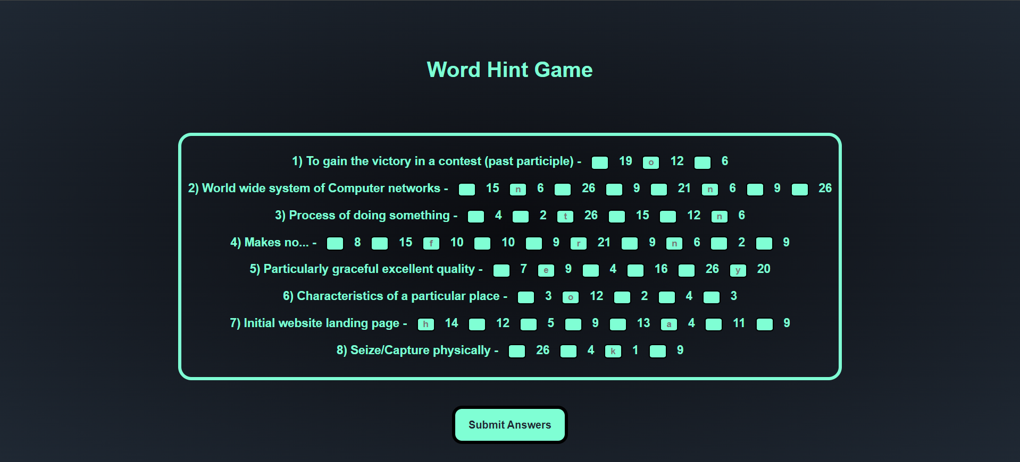

Level 3

<!DOCTYPE *html*>

<html>

<head>

    <title>Level2 Quiz</title>

<script *src***=**"https://ajax.googleapis.com/ajax/libs/jquery/3.7.1/jquery.min.js"></script>

<script>

    var quiztitle **=** "Guess The Country?"**;**

    var quiz **=** [

        {

            "question"      **:**   "HINT:The Birth Place Of Religions Like  Hinduism, Buddhism, Jainism, and Sikhism"**,**

            "image"         **:**   "https://thumbs.dreamstime.com/b/india-map-silhouette-vector-illustration-isolated-white-background-125706645.jpg"**,**

            "choices"       **:**   [

                                    "India"**,**

                                    "USA"**,**

                                    "China"**,**

                                    "Japan"

                                ]**,**

            "correct"       **:**   "India"**,**

            "explanation"   **:**   " INDIA - is the birth place of these 4 religions almost 25% of world population follows them. "**,**

            "correctimage"**:**"https://as1.ftcdn.net/v2/jpg/00/49/53/84/1000_F_49538425_9spq7apu4iOweBWGxuckkZ7vH4knh6Fh.jpg"**,**

        }**,**

      {

            "question"      **:**   "HINT:It has won most World Cup title in Cricket "**,**

            "image"         **:**   "aus.png"**,**

            "choices"       **:**   [

                                    "Greece"**,**

                                    "Australia"**,**

                                    "USA"**,**

                                    "Japan"

                                ]**,**

            "correct"       **:**   "Australia"**,**

            "explanation"   **:**   "Australia: their team won the most World Cup title i.e. 6 times. They won ICC Men's ODI World Cup in 1987, 1999, 2003, 2007, 2015 and 2023"**,**

              "correctimage"**:**"ausans.png"**,**

        }**,**

        {

            "question"      **:**   "HINT:The House Of King Ravana"**,**

            "image"         **:**   "https://www.shutterstock.com/image-vector/sri-lanka-outline-map-country-260nw-1169795866.jpg"**,**

            "choices"       **:**   [

                                    "Kuwait"**,**

                                    "Russia"**,**

                                    "Sri Lanka"**,**

                                    "Bhutan"

                                ]**,**

            "correct"       **:**   "Sri Lanka"**,**

            "explanation"   **:**   "Sri Lanka: It is believed that it was gifted to King Ravana by Lord Shiva After Being Impressed By his devotion."**,**

            "correctimage"**:**"sri.png"**,**

        }**,**

       {

            "question"      **:**   "HINT:It has the city of LOVE"**,**

            "image"         **:**   "france.png"**,**

            "choices"       **:**   [

                                    "England"**,**

                                    "USA"**,**

                                    "Maldives"**,**

                                    "France"

                                ]**,**

            "correct"       **:**   "France"**,**

            "explanation"   **:**   "France: It has the city of Love Paris,which is famous for the great Eiffel Tower."**,**

            "correctimage"**:**"franceans.png"**,**

        }**,**

      {

            "question"      **:**   "HINT:It is located between the European and Asian continents and thus called a transcontinental country."**,**

            "image"         **:**   "tuk.png"**,**

            "choices"       **:**   [

                                    "Türkiye"**,**

                                    "Russia"**,**

                                    "Sri Lanka"**,**

                                    "Bhutan"

                                ]**,**

            "correct"       **:**   "Türkiye"**,**

            "explanation"   **:**   "Türkiye: Only 3% of the land area lie in Europe, 97% of the country lie on the Asian continent."**,**

            "correctimage"  **:**"tukans.png"**,**

        }**,**

    ]**;**

    var currentquestion **=** 0**,** score **=** 0**,** submt**=**true**,** picked**;**

    document**.**addEventListener("DOMContentLoaded"**,** function(**event**) {

*//to print statements*

        function htmlEncode(**value**){

**return** document**.**createElement('div')**.**appendChild(document**.**createTextNode(value))**.***parentNode***.***innerHTML***;**

        }

*//the option block*

        function addChoices(**choices**){

**if**(**typeof** choices **!==** "undefined" **&&** Array**.**isArray(choices)){

                var choiceBlock **=** document**.**getElementById('choice-block')**;**

                choiceBlock**.***innerHTML* **=** ""**;**

**for**(var i**=**0**;**i**<**choices**.**length**;** i**++**){

                    var li **=** document**.**createElement('li')**;**

                    li**.***className* **=** 'choice choice-box'**;**

                    li**.**setAttribute('data-index'**,** i)**;**

                    li**.***textContent* **=** choices[i]**;**

                    li**.***style***.***backgroundColor***=**"white"**;**

                    choiceBlock**.**appendChild(li)**;**

                }

            }

        }

*//Resets all of the fields to prepare for next question*

        function nextQuestion(){

            submt **=** true**;**

            document**.**getElementById('explanation')**.***innerHTML* **=** ""**;**

            document**.**getElementById('question')**.***textContent* **=** quiz[currentquestion]['question']**;**

            document**.**getElementById('pager')**.***textContent* **=** 'Question ' **+** Number(currentquestion **+** 1) **+** ' of ' **+** quiz**.**length**;**

**if**(quiz[currentquestion]**.**hasOwnProperty('image') **&&** quiz[currentquestion]['image'] **!=** ""){

                var questionImage **=** document**.**getElementById('question-image')**;**

**if**(**!**questionImage){

                    questionImage **=** document**.**createElement('img')**;**

                    questionImage**.***className* **=** 'question-image'**;**

                    questionImage**.***id* **=** 'question-image'**;**

                    document**.**getElementById('frame')**.**appendChild(questionImage)**;**

                }

                questionImage**.***src* **=** quiz[currentquestion]['image']**;**

                questionImage**.***alt* **=** htmlEncode(quiz[currentquestion]['question'])**;**

            }

**else**

            {

                var questionImage **=** document**.**getElementById('question-image')**;**

**if**(questionImage)

                    questionImage**.**remove()**;**

            }

            addChoices(quiz[currentquestion]['choices'])**;**

            setupButtons()**;**

        }

*//After a selection is submitted, checks if its the right answer*

        function processQuestion(**choice**){

        var choiceElements **=** document**.**querySelectorAll('.choice')**;**

*//correct image*

        var questionImage **=** document**.**getElementById('question-image')**;**

**if**(quiz[currentquestion]['choices'][choice] **==** quiz[currentquestion]['correct']){

                choiceElements[choice]**.***style***.***backgroundColor* **=** '#50D943'**;**

                var audio **=** **new** Audio('correctans.mp3')**;** *// Path to your sound file*

            audio**.**play()**;** *// Play the sound*

                document**.**getElementById('explanation')**.***innerHTML* **=** '<strong>Correct!</strong> ' **+** htmlEncode(quiz[currentquestion]['explanation'])**;**

                score**++;**

        }

**else** {

                choiceElements[choice]**.***style***.***backgroundColor* **=** '#D92623'**;**

                var audio **=** **new** Audio('wrongans.mp3')**;** *// Path to your sound file*

            audio**.**play()**;** *// Play the sound*

                document**.**getElementById('explanation')**.***innerHTML* **=** '<strong>Incorrect.</strong> ' **+** htmlEncode(quiz[currentquestion]['explanation'])**;**

            }

            currentquestion**++;**

            var submitButton **=** document**.**getElementById('submitbutton')**;**

            submitButton**.***textContent* **=** 'Next Question»'**;**

            submitButton**.**onclick **=** function()

            {

**if**(currentquestion **==** quiz**.**length){

                    endQuiz()**;**

                }

**else** {

*this***.***textContent* **=** 'Check Answer'**;**

*this***.***style***.***color* **=** '#222'**;**

*this***.***onclick* **=** null**;**

                    nextQuestion()**;**

                }

            }

        }

*// formatting for each button.*

        function setupButtons(){

 var questionImage **=** document**.**getElementById('question-image')**;**

            var choiceElements **=** document**.**querySelectorAll('.choice')**;**

**for**(var i **=** 0**;** i **<** choiceElements**.**length**;** i**++**) {

                choiceElements[i]**.**onmouseover **=** function() {

*this***.***style***.***backgroundColor* **=** '#e1e1e1'**;**

                }**;**

                choiceElements[i]**.**onmouseout **=** function() {

*this***.***style***.***backgroundColor* **=** '#fff'**;**

                }**;**

                choiceElements[i]**.**onclick **=** function() {

                    picked **=** parseInt(*this***.**getAttribute('data-index'))**;**

**for**(var j **=** 0**;** j **<** choiceElements**.**length**;** j**++**) {

                        choiceElements[j]**.**removeAttribute('style')**;**

                        choiceElements[j]**.***style***.***backgroundColor***=**"#666257"**;**

                        choiceElements[j]**.***onmouseout* **=** choiceElements[j]**.***onmouseover* **=** null**;**

                    }

*this***.***style***.***borderColor* **=** '#222'**;**

*this***.***style***.***fontWeight* **=** '700'**;**

*this***.***style***.***backgroundColor* **=** '#bdb9af'**;**

**if**(submt){

                        submt**=**false**;**

                        var submitButton **=** document**.**getElementById('submitbutton')**;**

                        submitButton**.***style***.***color* **=** '#000'**;**

                        submitButton**.**onclick **=** function(){

                            changeImageWithFadeOutIn(questionImage**,** quiz[currentquestion]['correctimage'])**;**

**for**(var j **=** 0**;** j **<** choiceElements**.**length**;** j**++**) {

                                choiceElements[j]**.***onclick* **=** null**;**

                            }

*this***.***onclick* **=** null**;**

                            processQuestion(picked)**;**

                        }**;**

                    }

                }**;**

            }

        }

*//Quiz ends, display a message.*

        function endQuiz(){

             console**.**log("Executing endQuiz() function")**;**

            clearInterval(countdown)**;** *// Stop the timer*

            document**.**getElementById('explanation')**.***innerHTML* **=** ""**;**

            document**.**getElementById('question-image')**.**remove()**;**

            document**.**getElementById('status')**.**remove()**;**

            document**.**getElementById('pager')**.**remove()**;**

            document**.**getElementById('choice-block')**.***innerHTML* **=** ""**;**

            document**.**getElementById('question')**.***style***.***fontSize***=**'1.5em'**;**

            document**.**getElementById('question')**.***innerHTML* **=** "You got " **+** score **+** " out of " **+** quiz**.**length **+** " correct."**;**

            var percentage **=** Math**.**round(score**/**quiz**.**length **\*** 100)**;**

            var last**=** document**.**createElement('h2')**;**

            last**.***textContent* **=** percentage **+** '%'**;**

            last**.***style***.***textAlign* **=** 'center'**;**

            last**.***style***.***fontSize* **=** '25em'**;**

            document**.**getElementById('frame')**.**appendChild(last)**;**

            var submitButton **=** document**.**getElementById('submitbutton')**;**

            submitButton**.***parentNode***.**removeChild(submitButton)**;**

            document**.***body***.***style***.***background* **=** '#000'**;**

            playConfettiVideo()

var record **=** document**.**createElement('p')**;**

record**.***textContent***=**"Your Record: "**;**

record**.***id***=**"record"**;**

record**.***style***.***color***=**"white"**;**

frame**.**appendChild(record)**;**

var congratulationMessage **=** document**.**createElement('p')**;**

**if** (percentage **>=** 70) {

        congratulationMessage**.***textContent* **=** "Congratulations! You did great!"**;**

    } **else** {

        congratulationMessage**.***textContent* **=** "You can do better! Keep practicing!"**;**

}

   congratulationMessage**.***style***.***textAlign* **=** 'center'**;**

    congratulationMessage**.***style***.***fontSize* **=** '50px'**;**

    congratulationMessage**.***style***.***color* **=** "white"**;**

    frame**.**appendChild(congratulationMessage)**;**

        }

function changeImageWithFadeOutIn(**imageElement,** **newSrc**) {

        $(imageElement)**.**fadeOut(500**,** function() {

            $(*this*)**.**attr('src'**,** newSrc)**.**fadeIn(1000)**;**

        })**;**

    }

 function playConfettiVideo() {

            var confettiVideo **=** document**.**getElementById('confettiVideo')**;**

            confettiVideo**.***style***.***display* **=** 'block'**;**

        }

*// Runs the first time and creates all of the elements for the quiz*

*//initialization*

        function init(){

            var frame **=** document**.**getElementById('frame')**;**

*//add title*

            var h1 **=** document**.**createElement('h1')**;**

            h1**.***textContent* **=** quiztitle **||** "Quiz"**;**

            frame**.**appendChild(h1)**;**

*//add pager and questions*

            var pager **=** document**.**createElement('div')**;**

            pager**.***className* **=** 'pager'**;**

            pager**.***id* **=** 'pager'**;**

            pager**.***textContent* **=** 'Question 1 of ' **+** quiz**.**length**;**

            frame**.**appendChild(pager)**;**

            var h2 **=** document**.**createElement('h2')**;**

            h2**.***className* **=** 'question'**;**

            h2**.***id* **=** 'question'**;**

            h2**.***textContent* **=** quiz[0]['question']**;**

            frame**.**appendChild(h2)**;**

**if**(quiz[0]**.**hasOwnProperty('image') **&&** quiz[0]['image'] **!=** ""){

                var questionImage **=** document**.**createElement('img')**;**

                questionImage**.***className* **=** 'question-image'**;**

                questionImage**.***id* **=** 'question-image'**;**

                questionImage**.***src* **=** quiz[0]['image']**;**

                questionImage**.***alt* **=** htmlEncode(quiz[0]['question'])**;**

                frame**.**appendChild(questionImage)**;**

            }

            var explanation **=** document**.**createElement('p')**;**

            explanation**.***className* **=** 'explanation'**;**

            explanation**.***id* **=** 'explanation'**;**

            explanation**.***innerHTML* **=** '&nbsp;'**;**

            frame**.**appendChild(explanation)**;**

            var choiceBlock **=** document**.**createElement('ul')**;**

            choiceBlock**.***id* **=** 'choice-block'**;**

            frame**.**appendChild(choiceBlock)**;**

            addChoices(quiz[0]['choices'])**;**

            var submitButton **=** document**.**createElement('div')**;**

            submitButton**.***className* **=** 'choice-box'**;**

            submitButton**.***id* **=** 'submitbutton'**;**

            submitButton**.***textContent* **=** 'Check Answer'**;**

            submitButton**.***style***.***fontWeight* **=** '700'**;**

            submitButton**.***style***.***color* **=** '#222'**;**

            frame**.**appendChild(submitButton)**;**

            setupButtons()**;**

        }

         init()**;**

*//----------------------TIMER------------------------------------------*

        var timeLeft **=**45**;** *// Set the time limit in seconds*

    var countdown **=** setInterval(function() {

    document**.**getElementById('timers')**.***innerHTML* **=** timeLeft **+** " seconds"**;**

**if** (timeLeft **<=** 0) {

        clearInterval(countdown)**;** *// Stop the countdown*

        endQuiz() *// Call your function to end the quiz when time is up*

    } **else** {

        timeLeft**--;** *// Decrement after updating the displayed time*

    }

}**,** 1000)**;**

 })**;**

</script>

    <style *type***=**"text/css" *media***=**"all">

        html**,**body**,**div**,**span**,**h2**,**h3**,**h4**,**h5**,**h6**,**p**,**code**,**small**,**strike**,**strong**,**sub**,**sup**,**b**,**u**,**i

        {

           border**:**0**;**

           font-size**:**100%**;**

           font**:**inherit**;**

           vertical-align**:**baseline**;**

           margin**:**0px**;**padding**:**0**;**

        }

        body{

               background**:** url("https://png.pngtree.com/background/20230522/original/pngtree-dark-background-with-a-colorful-network-of-lines-and-dots-picture-image_2686588.jpg")**;**

               background-repeat**:**no-repeat**;**

               background-size**:**cover**;**

            }

        ol**,**ul{

               list-style**:**none**;**

            }

        strong{

                font-weight**:**700**;**

            }

*#frame*{

                display**:**block**;**

                height**:**640px**;**

                padding**:**5px**;**

                margin**:**11px 10px**;**

            }

        h1{

             font-size**:**50px**;**

             color**:**white**;**

             font-family**:**serif**;**

             font**:**normal bolds**;**

             text-align**:**center**;**

             border-bottom**:**3px solid **#999;**

             margin**:**5px**;**

             padding-bottom**:**14px**;**

             width**:**auto**;**

          }

        h2{

            font**:**italic bold **;**

            font-size**:**20px **;**

            letter-spacing**:** 1.5px**;**

            color**:**white**;**

            padding**:**0**;**

            text-align**:**left**;**

            margin**:**30px **;**

        }

        div*.pager*{

                   margin**:**5px**;**

                   padding**:**15px**;**

                   font**:**bold**;**

                   color**:**white**;**

                   font-size**:**22px**;**

                   position**:**absolute**;**

                   left**:**1330px**;**

                   bottom**:**20px**;**

                   background-color**:** rgba(255**,** 255**,** 255**,** 0.6)**;**

                   border-radius**:** 50px**;**}

        img*.question-image*{

                           display**:**block**;**

                           margin**:**7px**;**

                           margin-left**:**60px**;**

                           border**:**1px solid **#ccc;**

                           height**:**490px**;**

                           width**:**500px**;**

                           }

*#choice-block*{ display**:** grid**;**

                       grid**:** auto/ auto auto**;**

                       grid-gap**:** 15px 10px**;**

                       position**:**absolute**;**

                       left**:**660px**;**

                       top**:**320px**;**

                       list-style**:**none**;**

                       margin**:**0px**;**

                       padding**:**0px**;**

                       }

*#submitbutton*{

                      background**:#9ed6e8;**

                      padding**:**10px 80px**;**

                      position**:**absolute**;**

                      left**:**810px**;**

                      bottom**:**140px**;**

                      }

*#submitbutton:hover*{background**:#136580;**}

*#explanation*{

                       font-weight**:**bold**;**

                       color**:**white**;**

                       font-size**:**22px**;**

                       margin**:**0 auto**;**

                       padding**:**20px**;**

                       position**:**absolute**;**

                       top**:**200px**;**

                       left**:**650px**;**

                       line-height**:**2.0**;**

                    }

*.choice-box*{

                     text-align**:**center**;**

                     font-size**:**50px**;**

                     margin**:**1px**;**

                     padding**:**5px 120px**;**

                     border**:**1px solid **#666;**

                     border-radius**:**14px**;**

                     cursor**:**pointer**;**

                   }

*#timers* {

    font-size**:** 40px**;**

    font-weight**:** bold**;**

    color**:** white**;**

    background-color**:#0abfa7;**

    padding**:** 10px**;**

    border-radius**:** 50px**;**

    margin-bottom**:** 20px**;**

    text-align**:** center**;**

    position**:**absolute**;**

    top**:**140px**;**

    left**:**1250px**;**

    height**:**49px**;**

    width**:**200px**;**

}

*#status*{

    font-size**:** 20px**;**

    color**:** white**;**

    position**:**absolute**;**

    top**:**110px**;**

    left**:**1310px**;**

    height**:**49px**;**

    width**:**200px**;**

}

*#record*{

 font-size**:** 29px**;**

 position**:**absolute**;**

 top**:**153px**;**

 right**:**300px**;**

}

    </style>

</head>

<body>

    <div ***id*=**"frame" *role***=**"content"></div>

 <div ***id*=**"status">Time Left:</div>

 <div ***id*=**"timers"> 25 seconds</div>

    <video ***id*=**"confettiVideo" *width***=**"100%" *height***=**"100%" *autoplay* *loop* *muted* *style***=**"position: fixed; top: 0; left: 0; z-index: -1;display: none;">

        <source *src***=**"crackers.mp4" *type***=**"video/mp4">

        Your browser does not support the video tag.

    </video>

</body>

</html>

HTML Structure:

* Title and Libraries:
* The document starts with a title, "Level2 Quiz."
* It includes the jQuery library using <script> tags from a CDN.
* Quiz Content:
* The quiz has several questions, each with a hint, image, multiple choices, correct answers, explanations, and correct answer images.
* Each question is represented as an object in the quiz array.
* Quiz Interface Elements:
* The quiz interface includes a question title, image, choices, and an explanation.
* A pager shows the current question number out of the total number of questions.
* A timer displays the time left for each question.
* End of Quiz Section:
* After completing the quiz, the final score is displayed along with a congratulatory message and a confetti animation.
* A record paragraph is added to show the user's record.

JavaScript:

* Quiz Logic:
* The script initializes the quiz, sets up event listeners for user choices, processes questions, and manages the flow of the quiz.
* It handles correct and incorrect answers, updates the score, and displays explanations.
* Timer Functionality:
* The countdown interval function manages the countdown timer, updating the time left and ending the quiz when the time runs out.
* Animation and Image Change:
* The script includes functions to change images with fade-out and fade-in effects when transitioning between questions.
* CSS Styling:
* General Styling:
* Body background is set to a gradient image.
* Various styling for headers, paragraphs, and other elements to create an aesthetically pleasing layout.
* Quiz Styling:
* Styling for the pager, question, question image, choices, and the submit button.
* Colors, borders, and padding are used to enhance the visual appeal.
* Timer Styling:
* Styling for the timer and status display.
* Confetti Video Styling:
* The video element for the confetti animation is styled to cover the entire screen and placed behind other elements.
* Additional Features:
* Background music is played on correct and incorrect answers.
* A congratulatory message is displayed based on the user's performance.

Spinning wheel html

<html *lang***=**"en">

  <head>

    <meta *name***=**"viewport" *content***=**"width=device-width, initial-scale=1.0" />

    <title>Spin Wheel App</title>

*<!-- Google Font -->*

    <link

*href***=**"https://fonts.googleapis.com/css2?family=Poppins:wght@500;600&display=swap"

*rel***=**"stylesheet"

    />

*<!-- Stylesheet -->*

    <link *rel***=**"stylesheet" *href***=**"style_spin_wheel.css" />

  </head>

  <body>

    <div *class***=**"wrapper">

      <div *class***=**"container">

        <canvas ***id*=**"wheel"></canvas>

        <button ***id*=**"spin-btn">Spin</button>

        <img *src***=**"arrow.png" *alt***=**"spinner arrow" />

      </div>

      <div ***id*=**"final-value">

        <p>Click On The Spin Button To Start</p>

      </div>

    </div>

*<!-- Chart JS -->*

    <script *src***=**"https://cdnjs.cloudflare.com/ajax/libs/Chart.js/3.9.1/chart.min.js"></script>

*<!-- Chart JS Plugin for displaying text over chart -->*

    <script *src***=**"https://cdnjs.cloudflare.com/ajax/libs/chartjs-plugin-datalabels/2.1.0/chartjs-plugin-datalabels.min.js"></script>

*<!-- Script -->*

    <script *src***=**"script_spin_wheel.js"></script>

  </body>

</html>

* HTML Structure:
* Document Structure:

The document is written in HTML5 with the <html lang="en"> declaration.

The <head> section includes the necessary meta tags, title, Google Font link, and a link to an external stylesheet.

Viewport Meta Tag:

The viewport meta tag is included for responsive design, ensuring that the content adapts to various device widths.

* External Resources:

The document includes links to external resources, such as Google Fonts and Chart.js library.

* Body Content:

The main content is wrapped in a <div class="wrapper">.

Inside the wrapper, there is a <div class="container"> containing a <canvas> element for the wheel, a <button> with the id "spin-btn" to trigger the wheel spin, and an <img> element for the spinner arrow.

* Final Value Display:

There is a <div> with the id "final-value" to display the result or final value after

spinning the wheel

* External Scripts:
* Chart.js:

The document includes the Chart.js library using a CDN link. This library is commonly used for creating interactive charts.

* Chart.js Plugin (Datalabels):

Another Chart.js plugin, chartjs-plugin-datalabels, is included for displaying text labels over the chart.

* Custom Script:

The document includes a custom JavaScript file, "script_spin_wheel.js," which likely contains the logic for spinning the wheel and handling the results.

* Styling:
* External Stylesheet:

The document links to an external stylesheet, "style_spin_wheel.css," presumably containing the styling rules for the Spin Wheel App.

* Google Font:

The Google Font "Poppins" with weights 500 and 600 is imported for styling text on the page.

* Functionality:
* Canvas for Wheel:

The <canvas> element with the id "wheel" suggests that the spinning wheel graphics are rendered using HTML5 canvas.

* Spin Button:

The <button> with the id "spin-btn" likely triggers the wheel spin action.

* Final Value Display:

The <div> with the id "final-value" initially displays a message instructing users to click on the spin button.

* JavaScript Script:

The custom JavaScript script, "script_spin_wheel.js," is responsible for implementing the spin wheel functionality.

Spinning wheel css

* {

  padding**:** 0**;**

  margin**:** 0**;**

  box-sizing**:** border-box**;**

  font-family**:** "Poppins"**,** sans-serif**;**

}

body {

  height**:** 100vh**;**

  background**:** linear-gradient(135deg**,** **#c3a3f1,** **#6414e9**)**;**

}

*.wrapper* {

  width**:** 90%**;**

  max-width**:** 34.37em**;**

  max-height**:** 90vh**;**

  background-color**:** **#ffffff;**

  position**:** absolute**;**

  transform**:** translate(-50%**,** -50%)**;**

  top**:** 50%**;**

  left**:** 50%**;**

  padding**:** 3em**;**

  border-radius**:** 1em**;**

  box-shadow**:** 0 4em 5em rgba(27**,** 8**,** 53**,** 0.2)**;**

}

*.container* {

  position**:** relative**;**

  width**:** 100%**;**

  height**:** 100%**;**

}

*#wheel* {

  max-height**:** inherit**;**

  width**:** inherit**;**

  top**:** 0**;**

  padding**:** 0**;**

}

@keyframes rotate {

*100%* {

    transform**:** rotate(360deg)**;**

  }

}

*#spin-btn* {

  position**:** absolute**;**

  transform**:** translate(-50%**,** -50%)**;**

  top**:** 50%**;**

  left**:** 50%**;**

  height**:** 26%**;**

  width**:** 26%**;**

  border-radius**:** 50%**;**

  cursor**:** pointer**;**

  border**:** 0**;**

  background**:** radial-gradient(**#fdcf3b** 50%**,** **#d88a40** 85%)**;**

  color**:** **#c66e16;**

  text-transform**:** uppercase**;**

  font-size**:** 1.8em**;**

  letter-spacing**:** 0.1em**;**

  font-weight**:** 600**;**

}

img {

  position**:** absolute**;**

  width**:** 4em**;**

  top**:** 45%**;**

  right**:** -8%**;**

}

*#final-value* {

  font-size**:** 1.5em**;**

  text-align**:** center**;**

  margin-top**:** 1.5em**;**

  color**:** **#202020;**

  font-weight**:** 500**;**

}

@media screen and (max-width**:** 768px) {

*.wrapper* {

    font-size**:** 12px**;**

  }

  img {

    right**:** -5%**;**

  }

}

* Global Styles:

*: Applies a set of styles to all elements on the page, including resetting padding and margin, using the border-box model, and setting the font family to "Poppins."

* Body Styles:

body: Sets the background of the entire body to a linear gradient with colors #c3a3f1 and #6414e9, creating a gradient background.

* Wrapper Styles:

.wrapper: Styles the main container for the wheel and other elements.

width: 90% of the viewport width, with a maximum width of 34.37em.

max-height: 90% of the viewport height.

background-color: White background.

position: Positioned absolutely in the center of the viewport.

transform: Translates the center to the middle of the viewport.

padding: 3em.

border-radius: 1em, giving it rounded corners.

box-shadow: Adds a subtle box shadow.

* Container Styles:

.container: Styles the container for the wheel.

position: Relative positioning.

* Wheel Styles:

#wheel: Styles the wheel (presumably a canvas element).

max-height and width: Inherits from the container.

top and padding: Set to 0.

* Keyframes Animation:
* @keyframes rotate: Defines a rotation animation that rotates 360 degrees.

Used for animation, possibly for spinning the wheel.

* Spin Button Styles:

#spin-btn: Styles the spin button.

* Positioned absolutely in the center of the wrapper.

height and width: 26% of the wrapper size, creating a circular button.

border-radius: 50%, making it circular.

cursor: Pointer.

background: Radial gradient with two colors (#fdcf3b and #d88a40).

* color: Text color.
* text-transform: Uppercase.
* font-size, letter-spacing, font-weight: Typography styles.
* Spinner Arrow Styles:

img: Styles the spinner arrow image.

Positioned absolutely with a fixed width.

Positioned to the right of the wheel.

* Final Value Styles:
* #final-value: Styles the container for displaying the final value after spinning.

font-size, text-align, margin-top: Typography and spacing styles.

color: Text color.

font-weight: Font weight.

* Media Query (max-width: 768px):

Adjusts styles when the screen width is 768 pixels or less.

.wrapper font size is set to 12px.

Adjusts the position of the spinner arrow (img) for smaller screens

Spinning wheel javascript

const wheel **=** document**.**getElementById("wheel")**;**

const spinBtn **=** document**.**getElementById("spin-btn")**;**

const finalValue **=** document**.**getElementById("final-value")**;**

*//Object that stores values of minimum and maximum angle for a value*

const rotationValues **=** [

  { minDegree**:** 0**,** maxDegree**:** 30**,** value**:** 2 }**,**

  { minDegree**:** 31**,** maxDegree**:** 90**,** value**:** 1 }**,**

  { minDegree**:** 91**,** maxDegree**:** 150**,** value**:** 6 }**,**

  { minDegree**:** 151**,** maxDegree**:** 210**,** value**:** 5 }**,**

  { minDegree**:** 211**,** maxDegree**:** 270**,** value**:** 4 }**,**

  { minDegree**:** 271**,** maxDegree**:** 330**,** value**:** 3 }**,**

  { minDegree**:** 331**,** maxDegree**:** 360**,** value**:** 2 }**,**

]**;**

*//Size of each piece*

const data **=** [16**,** 16**,** 16**,** 16**,** 16**,** 16]**;**

*//background color for each piece*

var pieColors **=** [

  "#8b35bc"**,**

  "#b163da"**,**

  "#8b35bc"**,**

  "#b163da"**,**

  "#8b35bc"**,**

  "#b163da"**,**

]**;**

*//Create chart*

let myChart **=** **new** Chart(wheel**,** {

*//Plugin for displaying text on pie chart*

  plugins**:** [ChartDataLabels]**,**

*//Chart Type Pie*

  type**:** "pie"**,**

  data**:** {

*//Labels(values which are to be displayed on chart)*

    labels**:** [1**,** 2**,** 3**,** 4**,** 5**,** 6]**,**

*//Settings for dataset/pie*

    datasets**:** [

      {

        backgroundColor**:** pieColors**,**

        data**:** data**,**

      }**,**

    ]**,**

  }**,**

  options**:** {

*//Responsive chart*

    responsive**:** true**,**

    animation**:** { duration**:** 0 }**,**

    plugins**:** {

*//hide tooltip and legend*

      tooltip**:** false**,**

      legend**:** {

        display**:** false**,**

      }**,**

*//display labels inside pie chart*

      datalabels**:** {

        color**:** "#ffffff"**,**

        formatter**:** (**_,** **context**) **=>** context**.***chart***.***data***.***labels*[context**.***dataIndex*]**,**

        font**:** { size**:** 24 }**,**

      }**,**

    }**,**

  }**,**

})**;**

*//display value based on the randomAngle*

const valueGenerator **=** (**angleValue**) **=>** {

**for** (let i **of** rotationValues) {

*//if the angleValue is between min and max then display it*

**if** (angleValue **>=** i**.***minDegree* **&&** angleValue **<=** i**.***maxDegree*) {

      finalValue**.***innerHTML* **=** `<p>Value: ${i**.***value*}</p>`**;**

      spinBtn**.***disabled* **=** false**;**

**break;**

    }

  }

}**;**

*//Spinner count*

let count **=** 0**;**

*//100 rotations for animation and last rotation for result*

let resultValue **=** 101**;**

*//Start spinning*

spinBtn**.**addEventListener("click"**,** () **=>** {

  spinBtn**.***disabled* **=** true**;**

*//Empty final value*

  finalValue**.***innerHTML* **=** `<p>Good Luck!</p>`**;**

*//Generate random degrees to stop at*

  let randomDegree **=** Math**.**floor(Math**.**random() **\*** (355 **-** 0 **+** 1) **+** 0)**;**

*//Interval for rotation animation*

  let rotationInterval **=** window**.**setInterval(() **=>** {

*//Set rotation for piechart*

*/\**

*Initially to make the piechart rotate faster we set resultValue to 101 so it rotates 101 degrees at a time and this reduces by 1 with every count. Eventually on last rotation we rotate by 1 degree at a time.*

*\*/*

    myChart**.***options***.***rotation* **=** myChart**.***options***.***rotation* **+** resultValue**;**

*//Update chart with new value;*

    myChart**.**update()**;**

*//If rotation>360 reset it back to 0*

**if** (myChart**.***options***.***rotation* **>=** 360) {

      count **+=** 1**;**

      resultValue **-=** 5**;**

      myChart**.***options***.***rotation* **=** 0**;**

    } **else** **if** (count **>** 15 **&&** myChart**.***options***.***rotation* **==** randomDegree) {

      valueGenerator(randomDegree)**;**

      clearInterval(rotationInterval)**;**

      count **=** 0**;**

      resultValue **=** 101**;**

    }

  }**,** 10)**;**

})**;**

* DOM Elements Selection:

const wheel, spinBtn, finalValue: Variables to store references to the wheel canvas, spin button, and final value display elements, respectively.

* Rotation Values Configuration:

rotationValues: An array of objects, each representing a range of degrees on the wheel and its associated value.

* Pie Chart Configuration:
* The code uses the Chart.js library to create a pie chart.

myChart: Initializes a new Chart instance with the wheel canvas.

Data for the chart includes labels, background colors, and data values.

* Value Generator Function:

valueGenerator(angleValue): Displays the corresponding value based on the random angle where the wheel stops spinning.

* Event Listener (Spin Button):

Listens for a click event on the spin button.

Disables the button during spinning to prevent multiple spins.

Uses setInterval to rotate the pie chart for animation.

The chart rotation gradually slows down, and the final rotation angle is determined randomly.

* When the spinning stops, the corresponding value is displayed, and the interval is cleared.
* Variables:

count: Tracks the number of rotations.

resultValue: Controls the rotation speed for each interval.

